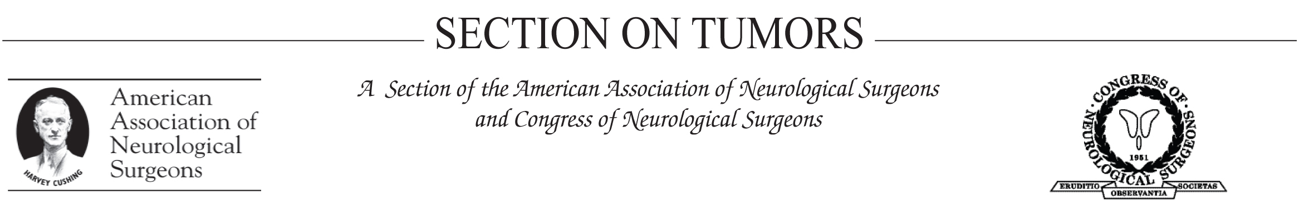
AANS/CNS Section on Tumors/BrainLAB International Research Fellowship Host Submission Form

The Tumor Section would like to establish a list from host institutions or laboratories in the U.S.A. and Canada who are interested in sponsoring a foreign neurosurgeon. The sponsoring investigator of the host laboratory will be required to submit a letter in support of the applicant, verifying the investigator’s willingness to mentor the applicant and provide necessary space and supplies for the applicant during the project/study period.

If you are a member of the AANS/CNS Tumor Section and are willing to be listed as a Host Institution/Sponsoring Investigator, please complete the application form below and return it to Kristen Weber at kaw@aans.org or by fax to 847-378-0640.

Physician Sponsor: _____________________________________________________

Institution/Organization Name: ___________________________________________

Contact Information:

Address: ______________________________________________________________

City: __________________________________ State: ______ Zip: ______________

E-mail: ________________________________ Phone: _________________________

Research Category: (please check all that apply)

Anatomic studies
Angiogenesis
Cell/Tumor biology
Delivery Methods
Experimental therapeutics
Immunology
Invasion
Outcome Studies
Pathology
Pediatric tumors
Preclinical models
Quality of Life
Radiation therapy
Radiology
Stem Cells
Tumor Genetics
Other: __________

Research Interest/Projects: please provide a summary of your research interests or areas of expertise with an emphasis on potential projects for applicants (500 word limit):

Please submit your Host Submission Form to Kristen Weber
at kaw@aans.org or by fax at 847-378-0640.

